**Introduction**

Windows of Opportunity is a web development company that specialize in designing and creating the best websites in the world. The company was founded by William Fence on April 1st, 1995. The headquarters is located in Redmond, WA, United States of America. Its main offices are located in Los Angeles, California, United States. It currently employs 15 workers including one manager, one assistant manager, a secretary, a receptionist, office accountants, 5 office workers and 5 web developers.

**Company Requirements**

Windows of Opportunity has asked for an upgraded network for their main office in Los Angeles. They’ve been using their third network, which was put in in 2001 and hasn’t been updated since. Windows of Opportunity would like a new network for improved work quality among staff and managers, as well as the opportunity for more profits to be made within the web development sector. Improved efficiency, which will help sharing files among workers and communication between colleagues, is another reason Windows of Opportunity wants a new network put into their offices.

**Aims**

One of the main aims for this will be to set up a Client Server for the company.

**Hardware/Software for Users**

What desktops and applications, operating systems will each group use

**Network Hardware/Software**

What is needed in the server room to connect clients?

**Floor Plan and Logical Layout**

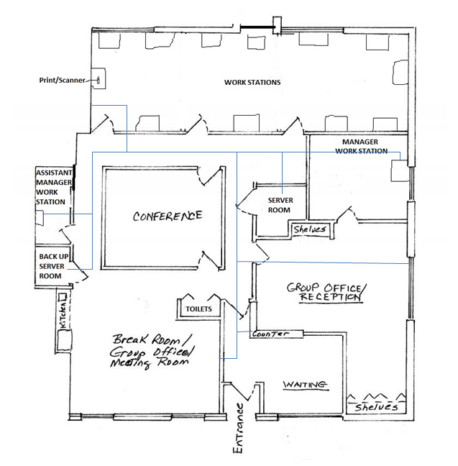

**Configuration/Analysis**

Steps to set it up (Explain)

**Conclusion and Recommendations**